Name:

Copy and Paste the following pictures/words to the appropriate box below.
Word and Picture Bank
Monitor |  | 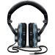
 | CPU Tower | Mouse

Picture | Word
 | printer
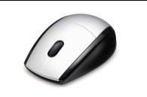
 | Keyboard

Picture | Word
 | Headphones
